# 02. Pawn Wars

## Rules

Before start solving this problem get familiar with a chessboard:

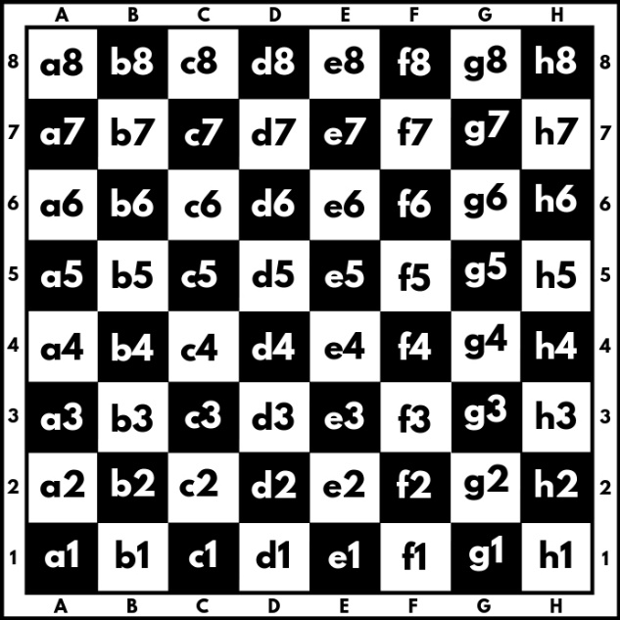

A chessboard has 8 rows and 8 columns. Rows also called ranks, are marked from number 1 to 8, and columns are marked from A to H. We have a total of 64 squares, each square is represented by a combination of letters and a number (a1, b1, c1, etc.). In this problem colors of the board will be ignored.

We will play the game with two pawns **white (w)** and **black (b)**, where they can:

* Only move forward:
  + - White (**w**) moves from the 1st rank to the 8th rank direction.
    - Black (**b**) moves from 8th rank to the 1st rank direction.
* Can move only 1 square at a time.
* Can capture another pawn only diagonally:

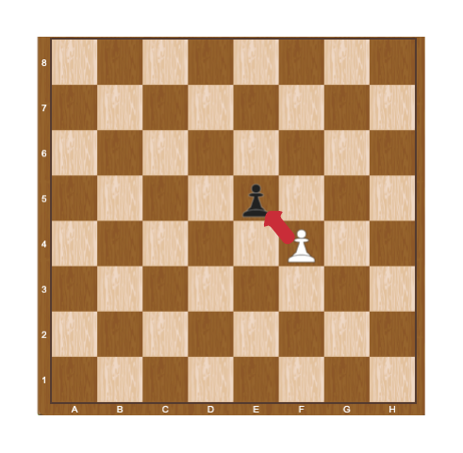

When a pawn reaches the **last rank**, for **white this is the 8th** rank, and **for black, this is the 1st** rank, can be **promoted** to a queen.

## Problem Description

Two pawns (**w** and **b**) will be placed on two random squares of the bord. The **first** move is always made by the **white pawn** (**w**), then black moves (b), then white (w) again, and so on. When **a pawn marches forward**, the **previous position** is marked by "-" (dash).

Some rules will be applied when moving paws:

* If the two pawns interact diagonally, the player, in turn, must capture the opponent’s pawn. When a pawn capture another pawn the game is over and "**Game over! {white/black} capture on {coordinates}.**" is printed to the console.

**Example:**

White pawn is on the move and captures black in "**e5**". We print "**Game over! White capture on e5.**"

* If no capture is possible, the pawns keep on moving until one of them reaches the last rank. When one of the pawns reaches the last rank we print: "**Game over! {White/Black} pawn is promoted to a queen at {coordinates}.**"

**Example:**

It is black**'**s turn and the pawn reaches the d1 square, we print "**Game over! Black pawn is promoted to a queen at d1.**"

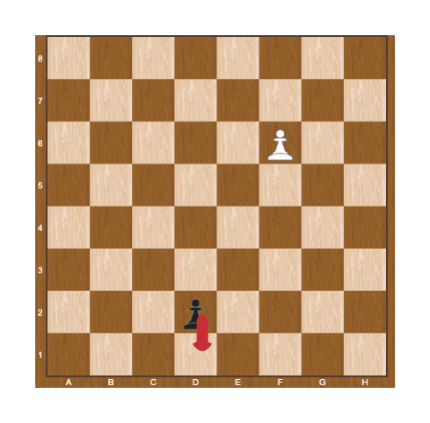

## Constraints

* The input will be always valid.
* The matrix will always be 8x8.
* There will be no case where two pawns are placed on the same square.
* There will be no case where two pawns are placed on the same column.
* There will be no case where black/white will be placed on the last rank.

## Examples

|  |  |  |
| --- | --- | --- |
| **Input** | **Output** | **Comments** |
| ------b-  --------  --------  --------  --------  -w------  --------  -------- | Game over! White pawn is promoted to a queen at b8. | We start by pushing the white pawn to b4, next, we push the black pawn to g7:  --------  ------b-  --------  --------  -w------  --------  --------  --------  Then white play b5, black play g6:  --------  --------  ------b-  -w------  --------  --------  --------  --------  …  Capturing is not possible here, so after a few more moves, the white pawn is promoted to a queen on b8. |
| --------  --------  --------  --------  --------  b-------  -w------  -------- | Game over! White capture on a3. | Here white captures black on a3 in the first move:  --------  --------  --------  --------  --------  w-------  --------  -------- |